**JUNE EXAM PERIOD 2022**

**JUNE 8,2022 (Wednesday), 13:00, Amphitheater SILOS**

* 100 questions (min 51 correct answers to pass exam)
* Duration of exam: two hours (120 min)
* Exam results - Faculty website, Thursday, June 9, 14:00
* Exam results will be signed in indexes on Friday, June 10, 10:00-11:00, Lab of Parasitol-Mycol (A Džamić)
* Stamp on mark index – Inst of Microbiol (Dr Subotića 1), ground floor,

Mrs Slavica Marjanović

* If you think you have **choose wrong answer**, you can mark another answer but **put your signature/initials BESIDE CORRECT ANSWER**

**CORRECTED ANSWER WITHOUT INITIALS WILL NOT BE ACCEPTED !**

* You can **correct a maximum of 7 questions**, 3 from bacteriology, 2 from parasitology-mycology and 2 from virology
* **Bringing indexes (identification) to the exam is compulsory !**
* **Be sure to bring fully completed white application form with you – also the back side**

**(full name, index number, and name of the subject – Medical Microbiology) !!!**

**(you cannot fill application form inside amphitheater !!!)**

* **WEARING OF MASK IS MANDATORY** **!**
* **Advice – just bring a pen with you; arrive on time on exam (amphitheater door should be locked 5 min after 13:00)**

Best,

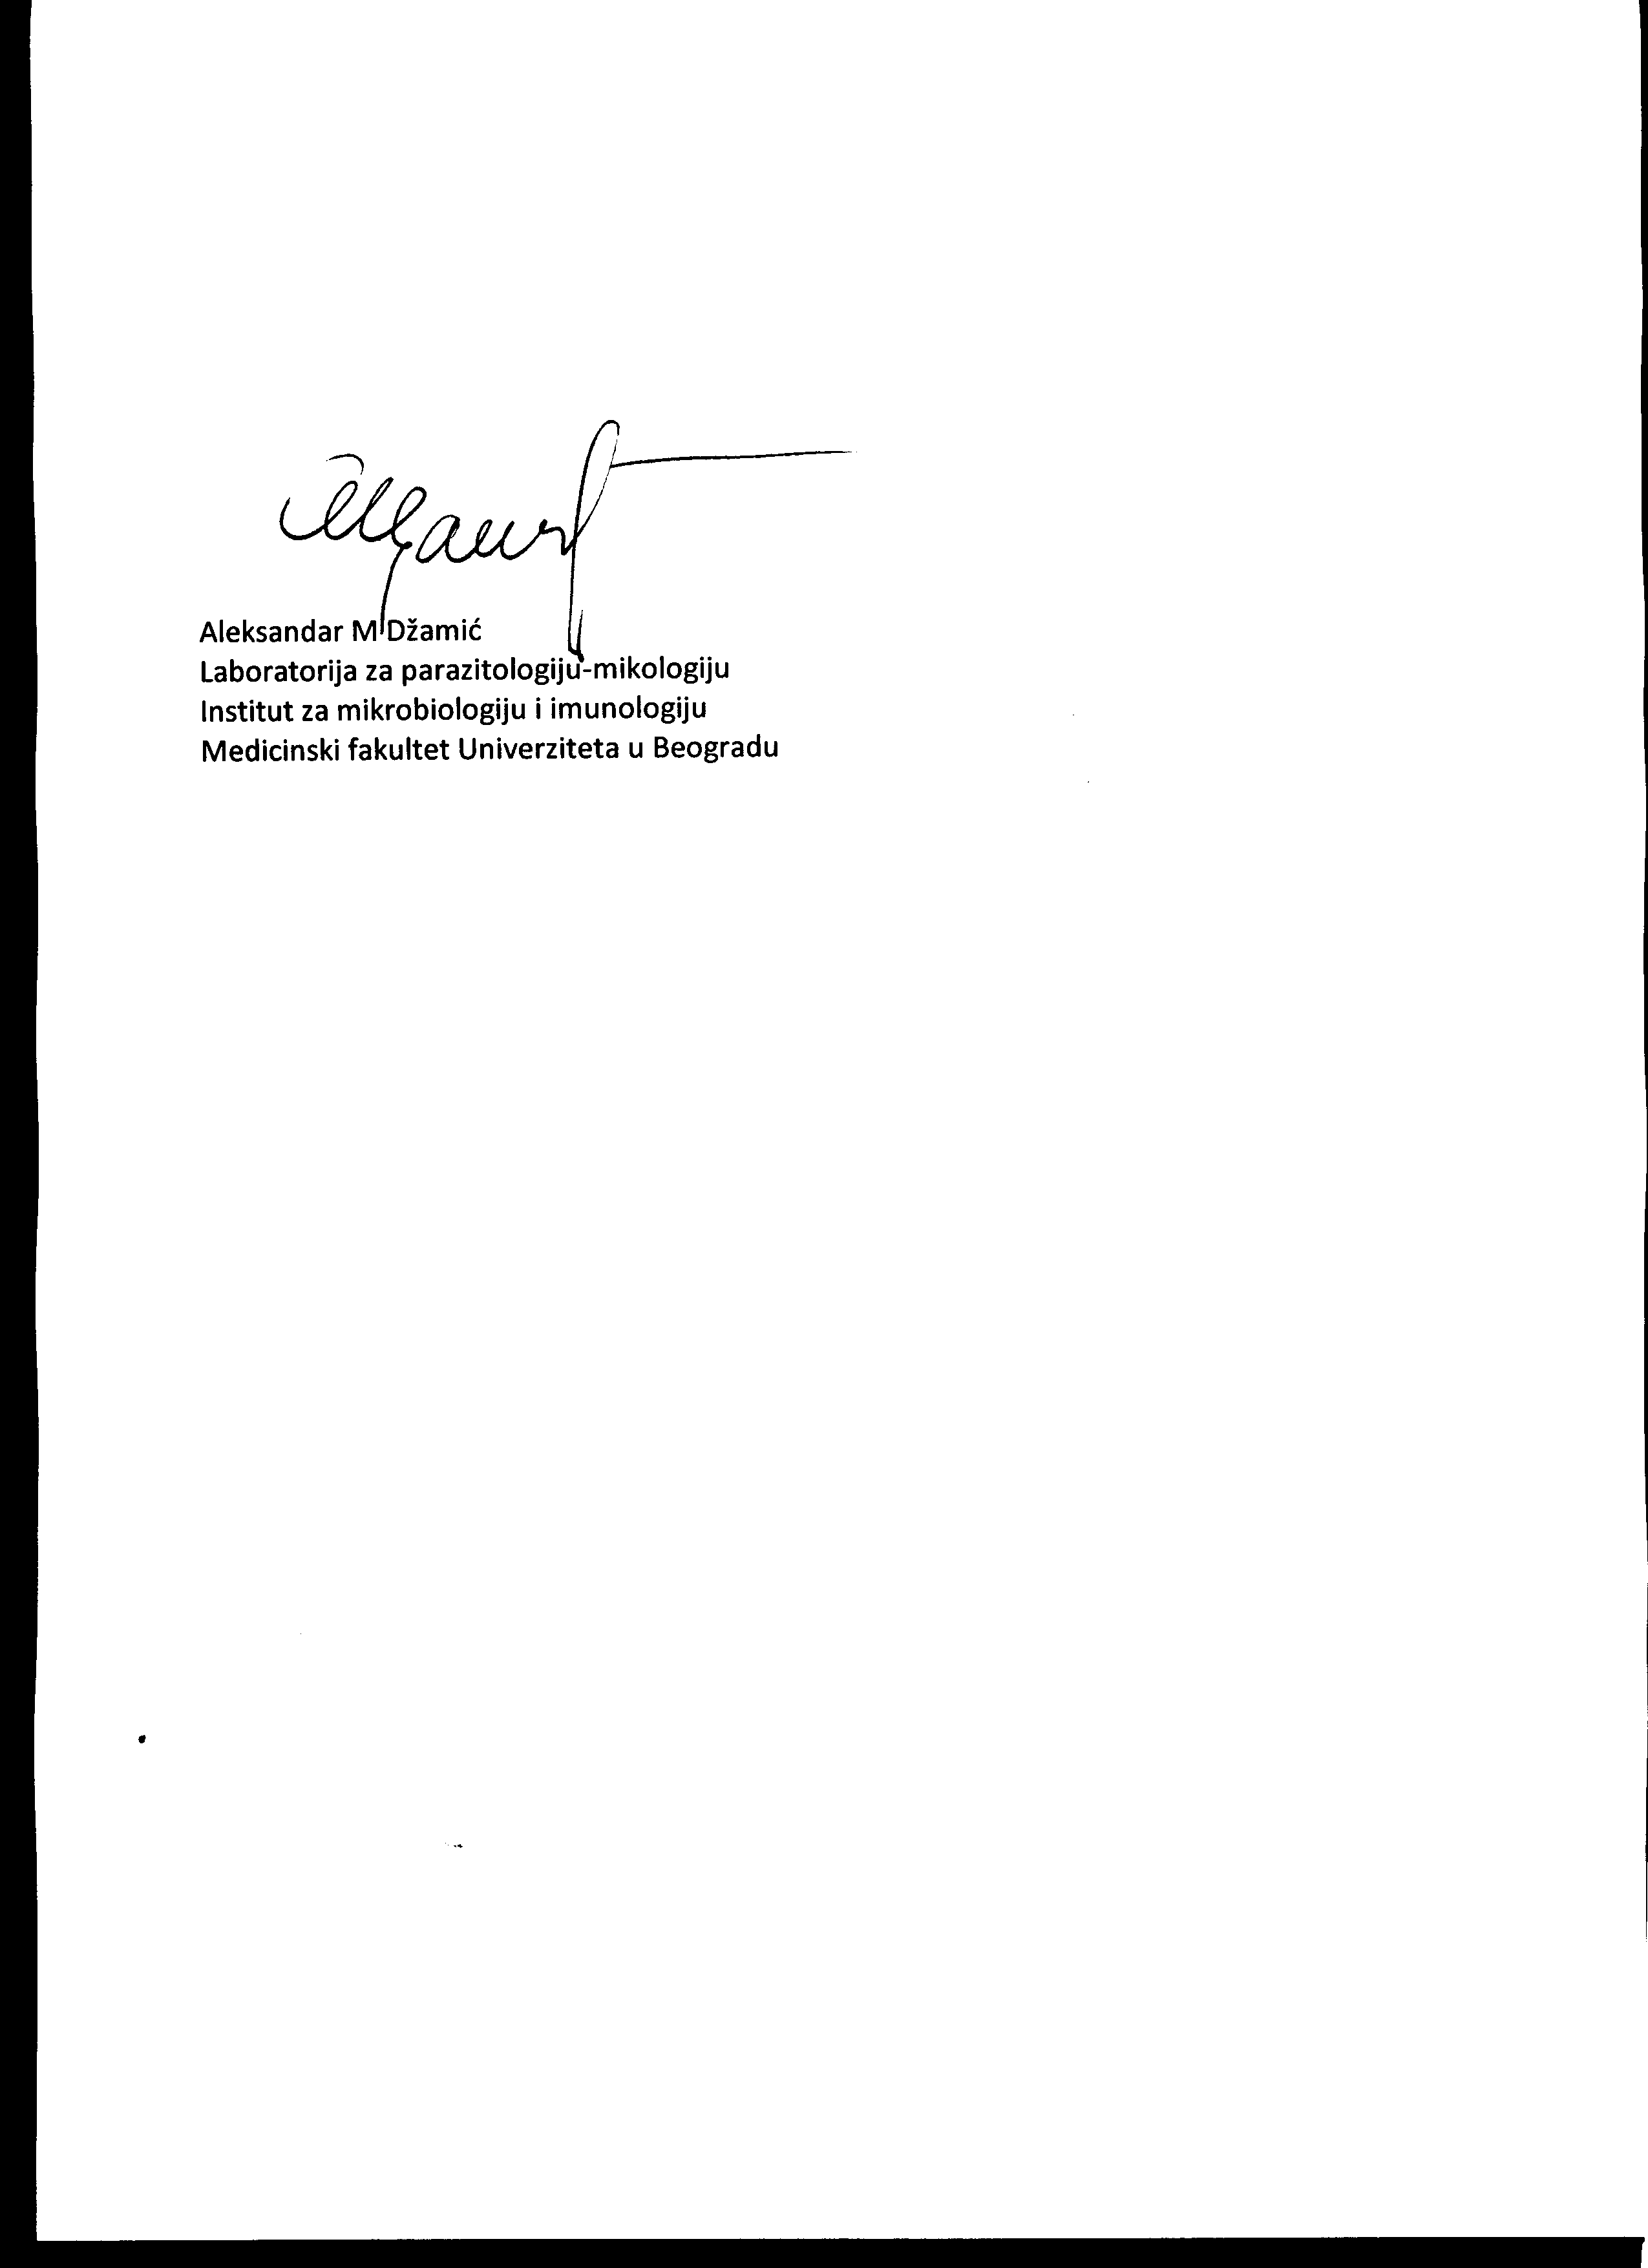

Prof AM Džamić June 3, 2022, Belgrade